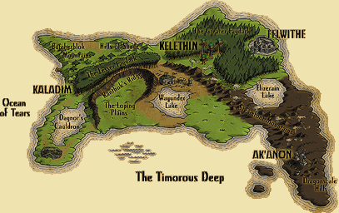

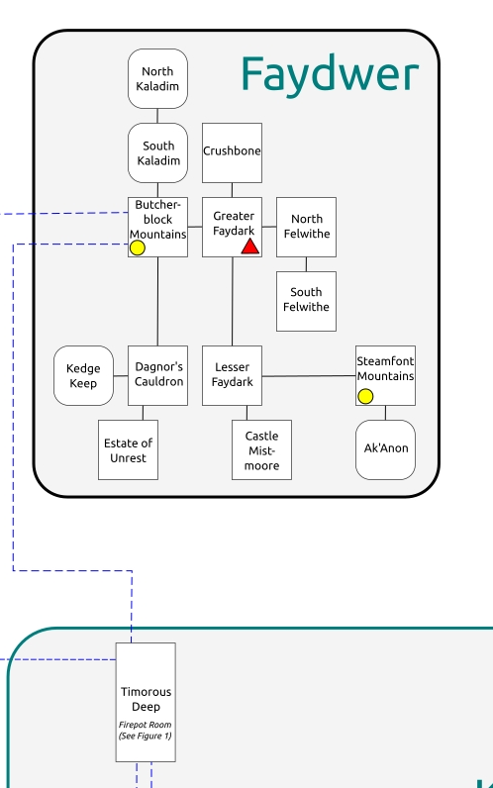

**Greater Faydark**

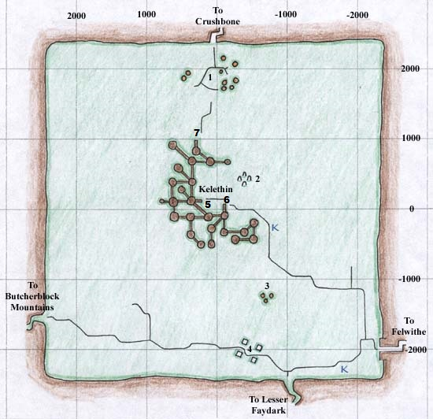

**Greater Faydark**

1. Orc Camps

2. Abandoned [Druid](https://wiki.project1999.com/Druid) Ring

3. Bandit Camp (-1260, -706)

4. [Wizard](https://wiki.project1999.com/Wizard) Spires

5. [PoD](https://wiki.project1999.com/Priest_of_Discord" \o "Priest of Discord) Lift

6. Newbie Lift

7. Orc Lift

**Kelethin**

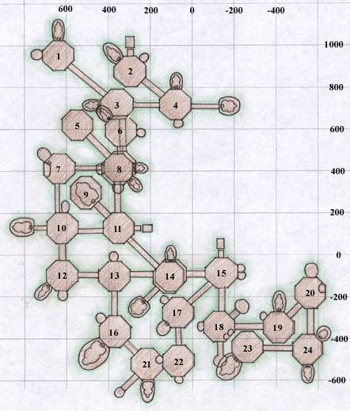

1. Abandoned Platform with Loom

2. Lift to ground - **"Orc Lift,"** Merchants selling Food and other Goods and Pottery Sketches, Inn

3. Merchants selling Elven Food Items, Food, and other Goods

4. Tavern selling Alcohol, Merchant selling Plate Armor

5. Merchants selling Racial Alcohol, Common Gems

6. Abandoned Platform

7. Tavern selling Alcohol, Merchant selling Plate Armor

8.-Upper (connects to platforms 5, 6, and 7) Sparkling Glass with Merchant selling Metals and Rare Gems, Merchants selling Elven Food, Oven

8.-Lower (connects to platforms 3 and 11) Pottery and Fletching Supply Merchants, [**Warrior**](https://wiki.project1999.com/Warrior)**Guild**

9. Heartwood Tavern selling Alcohol

10. Hut selling Food and other Goods, connected platform has Tavern selling Alcohol

11. **"**[**Priest of Discord**](https://wiki.project1999.com/Priest_of_Discord)**Lift aka PoD Lift,"** Merchants selling Medium Armor Molds, Sheet Metal, Food and other Goods

12. **Bank**, Merchant selling Potions and Crystals

13. Platform with [Rangers](https://wiki.project1999.com/Ranger)

14.-Upper (connects to platform 13) Abandoned Platform

14.-Lower (connects to platforms 11 and 15) Packwearers Goods selling Bags and Boxes, [**Bard**](https://wiki.project1999.com/Bard)**Guild** across bridge

15. **Newbie Lift**, Merchants selling Food, Milk and other Goods, [Large Sewing Kit](https://wiki.project1999.com/Large_Sewing_Kit), tailoring patterns and instructions

16. Faydark's Champions - [**Ranger**](https://wiki.project1999.com/Ranger)**Guild**

17. Inn with [Innkeep Wuleran](https://wiki.project1999.com/Innkeep_Wuleran" \o "Innkeep Wuleran) selling Food and other Goods, Forge, Merchant selling Potions and Crystals, Chain Mail Patterns, Weapons

18. Merchant selling Leather Armor and Sewing Patterns, Merchant in hut selling Bags and Boxes

19. Inn selling Food, including Muffins and other Goods

20. Shop selling [Smithing](https://wiki.project1999.com/Smithing" \o "Smithing) Books and Container, Weapon, and File Molds, Merchant selling Cloth Armor, Pottery Wheel and Kiln

21. Soldiers of Tunare - [**Druid**](https://wiki.project1999.com/Druid)**Guild**, Brew Barrel, bridge connects to Bilrio's Smithy selling Sharp and Blunt Weapons

22. Merchants selling Chain Mail Armor and Boots, also Fier'Dal Forge

23. Scouts of Tunare - [**Rogue**](https://wiki.project1999.com/Rogue)**Guild**, sells Throwing Weapons

24. Trueshot Bows selling Fletching (arrow) Supplies, Merchants selling Fletching (bows) Supplies, Tavern selling Alcohol and Ranger Spells

**Lesser Faydark**

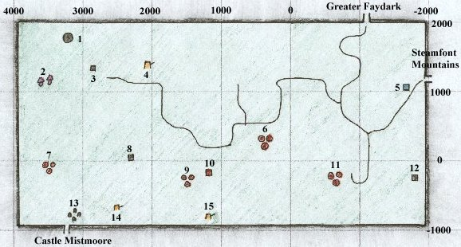

**Lesser Faydark**

1. Brownie Compound - Merchants who sell high level [Enchanter](https://wiki.project1999.com/Enchanter) spells (1775, 3100)

2. Faerie Village, with Gearheart

3. "Pixie Tower"

4. Bandit Camp (1390, 2075)

5. [Gnome](https://wiki.project1999.com/Gnome) Huts

6. Orc Camp

7. Orc Camp

8. Haunted Shrine

9. Orc Camp with Orc Chief

10. [Wood Elf](https://wiki.project1999.com/Wood_Elf) [Ranger](https://wiki.project1999.com/Ranger) Outpost selling Food and other goods (-280, 1255)

11. Orc Camp

12. Wood Elf Temple with Shadowed Men

13. Abandoned Stone Ring, inhabited by the Fae Royal Court

14. Bandit Camp with Bandit Sisters

15. Abandoned Camp of the Legendary Wu, now inhabited by Tier'Dal

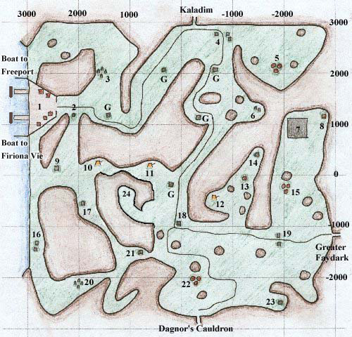

**Butcherblock Mountains**

1. Docks: Northern Pier leads to [Freeport](https://wiki.project1999.com/Freeport), Southern Pier leads to [Firiona Vie](https://wiki.project1999.com/Firiona_Vie" \o "Firiona Vie) in Kunark, Merchants that sell Food and other goods, also many houses representing all the races on Faydwer

2. Stone with Guard

3. Ancient Stone Ring, protected by Dwarves

4. Huts with Merchants who sell Food, Cookie Molds, Smithing Molds, Brewing Supplies and Books, and other Goods

5. Goblin Camp

6. Partially destroyed Ancient Stone Ring with a small level goblin camp. [A Crazed Goblin](https://wiki.project1999.com/A_Crazed_Goblin) spawns here.

7. The Chessboard *("renovated" on 7/14/2013 patch)*

9. Tower with Guards and High Elf Merchant selling Food and other goods

10. Bandit Camp with Peg Leg and others

11. Goblin Warrior Camp

12. Bandit Camp

13. Altar

14. Stone Pillar protected by Orcs

15. Goblin Camp

16. Dwarf Houses which sell Leather Armor and Sewing Patterns

17. Abandoned Guard House with [Signus Boran](https://wiki.project1999.com/Signus_Boran" \o "Signus Boran) inside

18. "The Crossroads" - Guard House with Nyzil Bloodforge

19. Merchants who sell Clay, Firing Sheets, Chain Armor, tailoring patterns, [Large Sewing Kit](https://wiki.project1999.com/Large_Sewing_Kit) and other goods

20. [Druid](https://wiki.project1999.com/Druid) Ring with Merchant selling [Druid](https://wiki.project1999.com/Druid) Spells

21. Haunted Tower

22. Goblin Camp, Spawn Point for Corflunk Placeholder

23. Stone Tower

24. Enraged Goblins

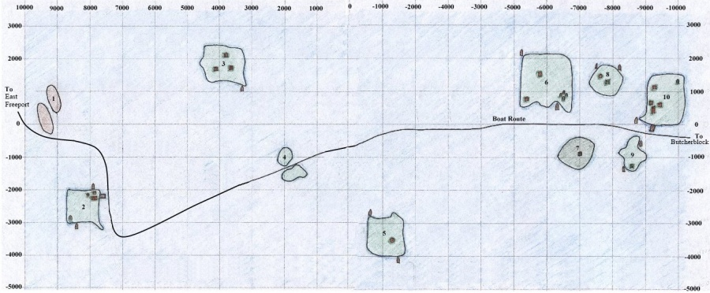

* 1. Several dozen small rocky outcroppings inhabited by Aqua Goblins, Alluring Sirens, and Nerbilik. Brawn also spawns here. There is no boat on these islands.
* 2. Docking point for boats coming from Freeport. Inn sells food and other goods. Stone in southwestern corner of island. Two boats.
* 3. Aviak Island. Three aviak towers and many roaming aviaks, as well as [Gull Skytalon](https://wiki.project1999.com/Gull_Skytalon) who drops [Ingot of the Fervent](https://wiki.project1999.com/Ingot_of_the_Fervent) and [Soarin Brightfeather](https://wiki.project1999.com/Soarin_Brightfeather" \o "Soarin Brightfeather) who drops [Ebon War Spear](https://wiki.project1999.com/Ebon_War_Spear).
* 4. Two rocky spires inhabited by Aqua Goblins and Alluring Sirens. There is no boat here.
* **NOTE: On P99, the east-bound boat will pass just south of the pair of spires at location 4, not through the middle as shown on the map.**
* 5. Island inhabited by Aqua Goblins. Temple on hill in middle of island. The [Allizewsaur](https://wiki.project1999.com/Allizewsaur" \o "Allizewsaur) (spawns at -3060, -660 with an aqua goblin placeholder) roams this island, spending most of its time on the hill near the temple. Two boats.
* 6. Island inhabited by Seafury Cyclops (who are placeholders for Tainted/Corrupt Cyclops), a Buccaneer (who is place holder for Wiltin Windwalker), Gornit, Goob Mudtoe, Quag Maelstrom and a camp of less-than friendly pirates (Toko Binlittle and pet, Dixl Drool, Capt. Surestout). Two boats. Ruined stone ring in southeastern corner.
* 7. Haunted island inhabited by Spectres and Gargoyles who worship at the dark tower. The Sentry spawns here rarely. Gargoyles share spawns with lower-level skeletons, but kill skeletons when their paths intersect. The island will often be full of gargoyles when no one has been killing them, but skeletons spawn respawn quite frequently.
* 8. Island with Boog Mudtoe and Pirate. Also has Temple on north side of hill and old ruined tower on top of hill inhabited by [Elesseryl Terussar](https://wiki.project1999.com/Elesseryl_Terussar" \o "Elesseryl Terussar) who sells Mage spells, mostly summoning spells. Pirate is placeholder for [Ancient Cyclops](https://wiki.project1999.com/Ancient_Cyclops).
* 9. Island of Isle Goblins and [A Goblin Headmaster](https://wiki.project1999.com/A_Goblin_Headmaster) and the [Oracle of K`Arnon](https://wiki.project1999.com/Oracle_of_K%60Arnon) and his Guardian. North point by guardian.
* 10. Island of the Sisters of Erollisi. Dock for boats coming from Antonica. One boat. Stone in northeastern corner. Dwarven smiths on western shore. Inn that sells goods and Kiola Nuts.

**Steamfront Mountains**

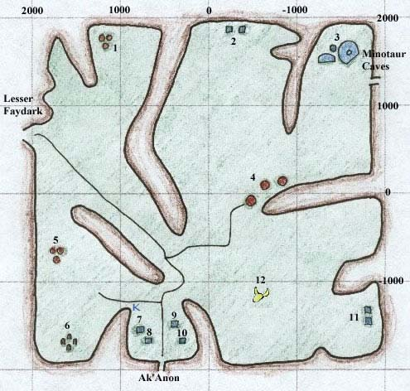

**Steamfont Mountains**

* 1. Kobold Camp
* 2. The Observers
* 3. Haunted Ruins of Giant Clockwork Machine
* 4. The Windmills of Steamfont, several Observers as well as Merchants who sell Ore, Medium-Quality Ore, Dye Materials, Sharpening Stones, Clay, and [Tinkering](https://wiki.project1999.com/Skill_Tinkering) Equipment
* 5. Kobold Camp
* 6. [Druid](https://wiki.project1999.com/Druid) Stone Ring with [Crisyn](https://wiki.project1999.com/Crisyn" \o "Crisyn) selling Spells
* 7. Merchant selling [Sewing](https://wiki.project1999.com/Skill_Tailoring) Supplies, including Large Sewing Kit, How To's, and Needle and Thimble Molds
* 8. Merchant selling Small Armor Molds
* 9. Merchant selling Cookie Molds
* 10. Merchant selling Food and other goods
* 11. Merchants selling Cooking Supplies and Gems for [Jewelry](https://wiki.project1999.com/Skill_Jewelcrafting)
* 12. Dragon Bones with Skeletons

**Dagnor’s Cauldron**

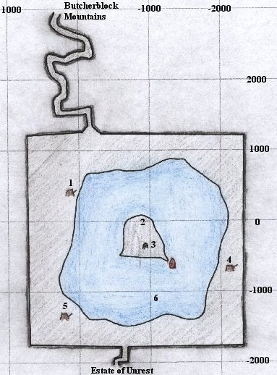

* 1. Friendly (to good races) NPC Camp and Healing
* 2. Thief NPC selling Poison
* 3. [Dwarven](https://wiki.project1999.com/Dwarf" \o "Dwarf) Stone Marker
* 4. Orc Scout Camp
* 5. Aqua Goblin Camp
* 6. [Kedge Keep](https://wiki.project1999.com/Kedge_Keep)

**Estate of Unrest**

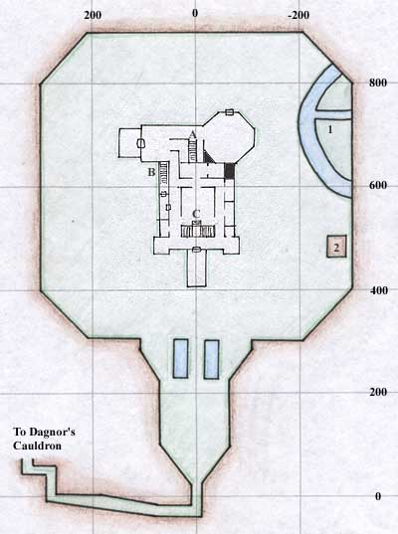

**Estate of Unrest**

* 1. Underground cave with a gnomish spelunker
* 2. The Gazebo
* A. Back Room area with the nearby rare spawn [lesser blade fiend](https://wiki.project1999.com/Lesser_Blade_Fiend) who drops [Gladius](https://wiki.project1999.com/Gladius) (Rare) and [Pugius](https://wiki.project1999.com/Pugius" \o "Pugius) (Rare)
* B. To Basement.
* C. Main Room or MR, and stairs to second floor.

The lettered stairs lead to each other.

**Unrest Manor**

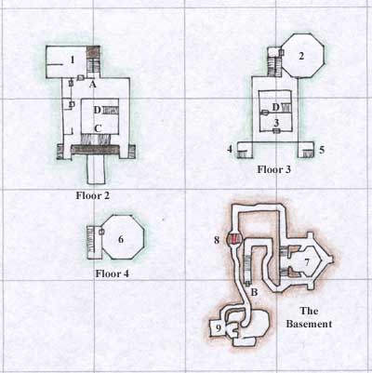

**Unrest Manor**

* 1. Room that spawns [reclusive ghoul magus](https://wiki.project1999.com/Reclusive_ghoul_magus) who drops [Savant's Cap](https://wiki.project1999.com/Savant%27s_Cap) (Common) and [Dusty Bloodstained Gloves](https://wiki.project1999.com/Dusty_Bloodstained_Gloves) (Rare)
* 2. Barroom where spawns: [an undead barkeep](https://wiki.project1999.com/An_undead_barkeep) who drops [Opalline Earring](https://wiki.project1999.com/Opalline_Earring" \o "Opalline Earring) (Common) and [Thick Leather Apron](https://wiki.project1999.com/Thick_Leather_Apron) (Rare), and Zombie of Unrest Noble
* 3. Room with [a reanimated hand](https://wiki.project1999.com/A_reanimated_hand) which drops [Ivory Bracelet](https://wiki.project1999.com/Ivory_Bracelet)
* 4. Tower that spawns [a priest of najena](https://wiki.project1999.com/A_priest_of_najena) who drops Tarnished Bronze Key
* 5. Tower Room
* 6. "Tower" with [an undead knight of Unrest](https://wiki.project1999.com/An_undead_knight_of_Unrest) who drops [Bloodstained Mantle](https://wiki.project1999.com/Bloodstained_Mantle) (Common) and [Bloodstained Tunic](https://wiki.project1999.com/Bloodstained_Tunic) (Rare)
* 7. Main Basement Room, filled with Werebats and Festering Hags
* 8. Blood Trap, be sure to walk *through* the lava, going around it will make you fall in pits
* 9. "Dwarf Room" with [Garanel Rucksif](https://wiki.project1999.com/Garanel_Rucksif" \o "Garanel Rucksif) who drops [Jagged Band](https://wiki.project1999.com/Jagged_Band) (Common) and [Dwarven Work Boots](https://wiki.project1999.com/Dwarven_Work_Boots" \o "Dwarven Work Boots) (Rare), also has Tentacle Terrors who drop [Tentacle Whip](https://wiki.project1999.com/Tentacle_Whip), and Dark Terrors
* A. Fireplace or FP, and stairs to first and second floors.

**Kedge Keep**

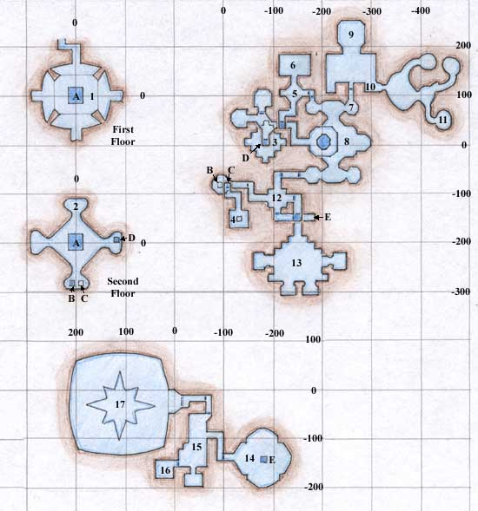

A. "The Hole" a shaft that goes down from First Floor to Second Floor and keeps going down into the "Piranha Pit" where Stiletto Fang Piranha spawns

B. Shaft down from Second Floor

C. Shaft up from Second Floor to #4

D. "Bubble's Tube" a shaft down from Second Floor to opening to north and eventually to #3

E. Shaft up to #14

1. "First Floor" with [Fierce Impaler](https://wiki.project1999.com/Fierce_Impaler) who drops [Gloomwater Harpoon](https://wiki.project1999.com/Gloomwater_Harpoon" \o "Gloomwater Harpoon) (Common) and [Darksea Harpoon](https://wiki.project1999.com/Darksea_Harpoon" \o "Darksea Harpoon) (Rare)

2. "Second Floor"

3. "Bubble's Den" with [Cauldronbubble](https://wiki.project1999.com/Cauldronbubble" \o "Cauldronbubble) who drops [Sharkbone Warhammer](https://wiki.project1999.com/Sharkbone_Warhammer" \o "Sharkbone Warhammer) (Common) and [Hammerhead Helm](https://wiki.project1999.com/Hammerhead_Helm) (Rare)

4. Room with [Golden Haired Mermaid](https://wiki.project1999.com/Golden_Haired_Mermaid) who drops [Lock of Hair](https://wiki.project1999.com/Lock_of_Hair)

5. "Fallen Gate Room" with shaft to east which leads downwards

6. "Safe Den"

7. "The Balcony" which is a common pull spot for Estrella

8. "Estrella's Temple" with [Estrella of Gloomwater](https://wiki.project1999.com/Estrella_of_Gloomwater) who drops [Rod of Drones](https://wiki.project1999.com/Rod_of_Drones) (Common) and [Lamentation Blade](https://wiki.project1999.com/Lamentation_Blade) (Common) and [Prayer Shawl](https://wiki.project1999.com/Prayer_Shawl) (Rare) and [Shellara Ebbhunter](https://wiki.project1999.com/Shellara_Ebbhunter" \o "Shellara Ebbhunter) who drops [Gloomwater Arrow](https://wiki.project1999.com/Gloomwater_Arrow" \o "Gloomwater Arrow) (Common) and [Pearlescent Mask](https://wiki.project1999.com/Pearlescent_Mask) (Rare)

9. "Temple of Prexus" with [Undertow](https://wiki.project1999.com/Undertow) who drops [Blazing Wand](https://wiki.project1999.com/Blazing_Wand) (Common) and [Squallsurge Shawl](https://wiki.project1999.com/Squallsurge_Shawl" \o "Squallsurge Shawl) (Rare)

10. Spawn spot of [Coralyn Kelpmaiden](https://wiki.project1999.com/Coralyn_Kelpmaiden" \o "Coralyn Kelpmaiden) who drops [Sharkbone Warhammer](https://wiki.project1999.com/Sharkbone_Warhammer" \o "Sharkbone Warhammer) (Common) and [Sharkskin Drum](https://wiki.project1999.com/Sharkskin_Drum) (Rare)

11. "Seahorse Caves" with [Seahorse Matriarch](https://wiki.project1999.com/Seahorse_Matriarch) who drops [Rod of Health](https://wiki.project1999.com/Rod_of_Health) (Common) and [Shield of Prexus](https://wiki.project1999.com/Shield_of_Prexus) (Rare)

12. "The Crossroads" with [a frenzied bull shark](https://wiki.project1999.com/A_frenzied_bull_shark) who drops [Abalone Gorget](https://wiki.project1999.com/Abalone_Gorget) (Rare)

13. "Boil's Lair" with [Cauldronboil](https://wiki.project1999.com/Cauldronboil" \o "Cauldronboil) who drops [Sharkjaw Cutlass](https://wiki.project1999.com/Sharkjaw_Cutlass" \o "Sharkjaw Cutlass) (Common) and [Kedgemail Gauntlets](https://wiki.project1999.com/Kedgemail_Gauntlets" \o "Kedgemail Gauntlets) (Rare)

14. "Frenzied Room" with [Frenzied Cauldron Shark](https://wiki.project1999.com/Frenzied_Cauldron_Shark) who drops [Shark Tooth](https://wiki.project1999.com/Shark_Tooth) (Common) and [Abalone Gorget](https://wiki.project1999.com/Abalone_Gorget) (Rare)

15. "Patriarch's Room" with [Seahorse Patriarch](https://wiki.project1999.com/Seahorse_Patriarch) who drops [Wand of Ice](https://wiki.project1999.com/Wand_of_Ice) (Common) and [Seahorse Scale Cloak](https://wiki.project1999.com/Seahorse_Scale_Cloak) (Rare)

16. "Ferocious Room" with [a ferocious hammerhead](https://wiki.project1999.com/A_ferocious_hammerhead) who drops [Wand of Shadow](https://wiki.project1999.com/Wand_of_Shadow) (Common) and [Driftwood Treasure Chest](https://wiki.project1999.com/Driftwood_Treasure_Chest) (Rare)

17. Room with **[Phinigel Autropos](https://wiki.project1999.com/Phinigel_Autropos" \o "Phinigel Autropos)** who drops [Blue Crystal Staff](https://wiki.project1999.com/Blue_Crystal_Staff) (Wizard Epic), [Kedge Backbone](https://wiki.project1999.com/Kedge_Backbone) (Bard Epic), [Robe of the Kedge](https://wiki.project1999.com/Robe_of_the_Kedge) (Rogue Epic), [Rod of Malisement](https://wiki.project1999.com/Rod_of_Malisement), [Staff of Elemental Mastery: Water](https://wiki.project1999.com/Staff_of_Elemental_Mastery:_Water), [Trident of the Seven Seas](https://wiki.project1999.com/Trident_of_the_Seven_Seas), [Wand of Mana Tapping](https://wiki.project1999.com/Wand_of_Mana_Tapping), [Fusible Coral Ore](https://wiki.project1999.com/Fusible_Coral_Ore)

18. In the room south of the "Patriarch's Room" there is a spawn point for the 'frenzied shark' which drops the [Abalone Gorget](https://wiki.project1999.com/Abalone_Gorget) just like [a frenzied bull shark](https://wiki.project1999.com/A_frenzied_bull_shark). It's placeholder can be a sailfin or a cauldron hammerhead. (Note - this is not the room with [a ferocious hammerhead](https://wiki.project1999.com/A_ferocious_hammerhead) spawn).

**Castle Mistmoore**

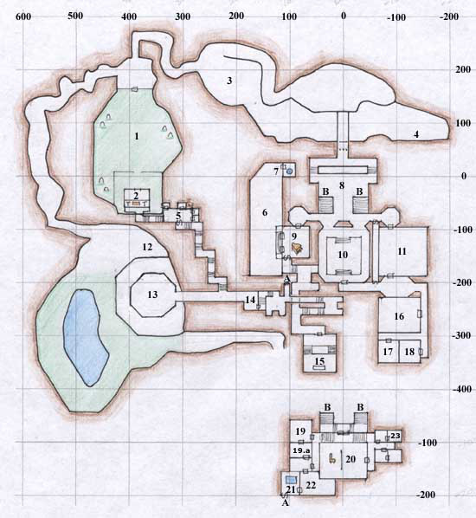

**Castle Mistmoore**

1. "Graveyard" (GY) where [an imp familiar](https://wiki.project1999.com/An_imp_familiar) spawns, who drops [Sacrificial Dagger](https://wiki.project1999.com/Sacrificial_Dagger) (Common) and [Bloodstone Eyepatch](https://wiki.project1999.com/Bloodstone_Eyepatch) (Rare), and [a glyphed ghoul](https://wiki.project1999.com/A_glyphed_ghoul), who drops [Vial of Vampire Blood](https://wiki.project1999.com/Vial_of_Vampire_Blood) (Common) and [Crested Mistmoore Shield](https://wiki.project1999.com/Crested_Mistmoore_Shield) (Rare)

2. Tomb with Coffin; behind it is [Ssynthi](https://wiki.project1999.com/Ssynthi" \o "Ssynthi) who drops [Robe of the Keeper](https://wiki.project1999.com/Robe_of_the_Keeper), and a Secret Entrance leading one way to the Jail

3. "The Pit"

4. "The Canyon" where [Black Dire](https://wiki.project1999.com/Black_Dire) spawns, as well as [Enynti](https://wiki.project1999.com/Enynti" \o "Enynti), who drops [Rune of Fortune](https://wiki.project1999.com/Rune_of_Fortune) (Rare)

5. "Jail" where [a deathly usher](https://wiki.project1999.com/A_deathly_usher) spawns, who drops [Black Silk Gloves](https://wiki.project1999.com/Black_Silk_Gloves), secret door has trap that strips off invisibility spells, Stairs is where [an avenging caitiff](https://wiki.project1999.com/An_avenging_caitiff) spawns who drops [Crested Spaulders](https://wiki.project1999.com/Crested_Spaulders) (Common) and [Crested Helm](https://wiki.project1999.com/Crested_Helm) (Rare). A ground spawn for Cleric quest [Caduceus of Sacrament](https://wiki.project1999.com/Caduceus_of_Sacrament_Quest) is here

6. "Courtyard" (CY) where [A Hemo Enologist](https://wiki.project1999.com/A_Hemo_Enologist) spawns, drops [Blood Spirit](https://wiki.project1999.com/Blood_Spirit).

7. Fountain where [a cloaked dhampyre](https://wiki.project1999.com/A_cloaked_dhampyre) spawns, drops [Blood of the Dhampyre](https://wiki.project1999.com/Blood_of_the_Dhampyre) (Common) and [Hooded Black Cloak](https://wiki.project1999.com/Hooded_Black_Cloak) (Rare). Spawn location of [A Fallen Noble](https://wiki.project1999.com/A_Fallen_Noble) who drops [Noble's Robes](https://wiki.project1999.com/Noble%27s_Robes) (Uncommon) and [Vial of Noble's Blood](https://wiki.project1999.com/Vial_of_Noble%27s_Blood) (Uncommon)

8. Entry Hall

9. "Piano"

10. "Ballroom" where gypsies and [Mynthi Davissi](https://wiki.project1999.com/Mynthi_Davissi" \o "Mynthi Davissi) spawn, drops [Lute of the Gypsy Princess](https://wiki.project1999.com/Lute_of_the_Gypsy_Princess) (Common) and [Mistmoore Battle Drums](https://wiki.project1999.com/Mistmoore_Battle_Drums" \o "Mistmoore Battle Drums) (Rare)

11. "Ambassador Room" where Negotiator and Gypsy Ambassador spawn

12. "The Corner"

13. "The Tower" where [Garton Viswin](https://wiki.project1999.com/Garton_Viswin" \o "Garton Viswin) spawns, drops [Glowing Iron Pike](https://wiki.project1999.com/Glowing_Iron_Pike) (Common) and [Chestplate of the Dark Flame](https://wiki.project1999.com/Chestplate_of_the_Dark_Flame" \o "Chestplate of the Dark Flame) (Rare)

14. Torture Chamber

15. Mayong Mistmoore's Coffin Room

16. Kitchen

17. Servant Room where [Maid Issis](https://wiki.project1999.com/Maid_Issis) spawns, drops [Nightshade Wreath](https://wiki.project1999.com/Nightshade_Wreath) (Common) and [Maid Issis Fang](https://wiki.project1999.com/Maid_Issis_Fang) (Rare)

18. Servant Room where [Butler Syncall](https://wiki.project1999.com/Butler_Syncall) spawns, drops [Cape of Midnight Mist](https://wiki.project1999.com/Cape_of_Midnight_Mist) (Common) and [Butler Syncalls Fang](https://wiki.project1999.com/Butler_Syncalls_Fang) (Rare)

19. Library

19.a Advisor room where [an advisor](https://wiki.project1999.com/An_advisor) spawns who drops [Advisor Robe](https://wiki.project1999.com/Advisor_Robe)

20. Throne Room where [Princess Cherista](https://wiki.project1999.com/Princess_Cherista) spawns, drops [Gem-Encrusted Scepter](https://wiki.project1999.com/Gem-Encrusted_Scepter) (Uncommon) and [Diamondine Earring](https://wiki.project1999.com/Diamondine_Earring" \o "Diamondine Earring) (Rare)

21. "The Bath" where [Lasna Cheroon](https://wiki.project1999.com/Lasna_Cheroon" \o "Lasna Cheroon) spawns, who drops [Diamondine Earring](https://wiki.project1999.com/Diamondine_Earring" \o "Diamondine Earring) (Common) and [Platinum Skull Ring](https://wiki.project1999.com/Platinum_Skull_Ring) (Rare), and [Xicotl](https://wiki.project1999.com/Xicotl" \o "Xicotl), who drops Hilt of Soulfire

22. Bedroom

23. [a dark ass`t librarian](https://wiki.project1999.com/A_dark_ass%60t_librarian) spawns who drops [Illegible Scroll](https://wiki.project1999.com/Illegible_Scroll) ("Vok Na Zov XI")